Order Form
St. Joseph Parish Music Ministry CD Vol II

Full Name

First Name Last Name

E-mail

Contact Number

Area Code Phone Number

Mailing Address

Street Address

Street Address
Street Address Line 2

Postal/ Zip Code Country
St. Joseph Parish Music Ministry CD

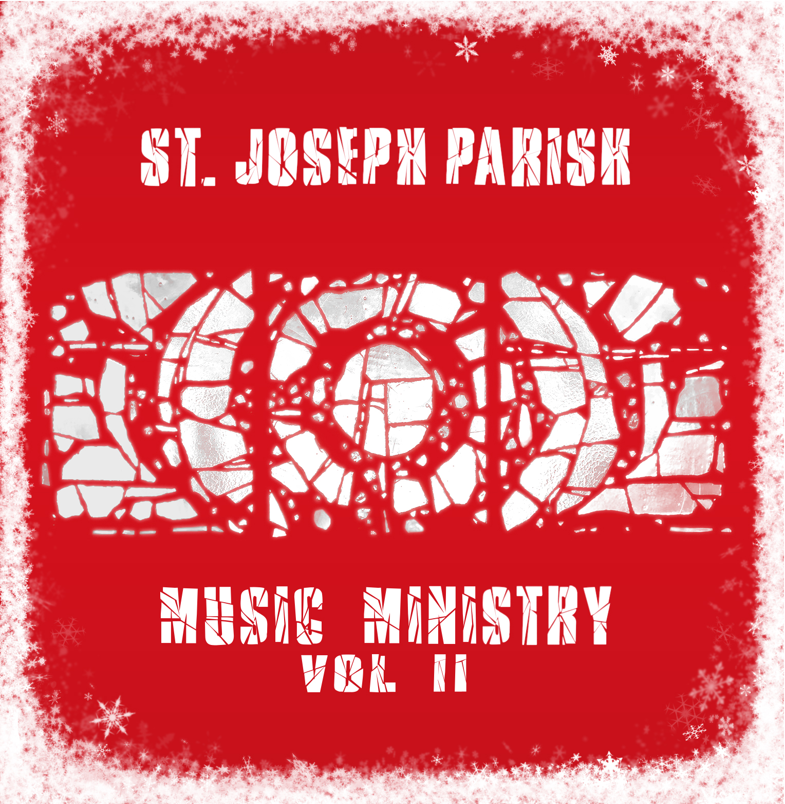
Quantity
Price per CD $20.00
Shipping is FREE

Check Total

Checks can be made out to St. Joseph Parish

Please mail checks and order forms to St. Joseph Parish, Attn: Music Director 173 Albion Street, Wakefield MA 01880

St. Joseph Parish, 173 Albion Street, Wakefield, MA 01880 Phone: 781-245-5770 Fax: 781-246-2423

